Dr. Pallabi Sarmah (PT), Assistant professor 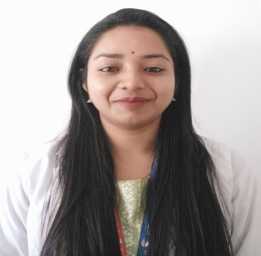

Qualification:
Masters of Physiotherapy in Community Based Rehabilitation (2014-18), College of Physiotherapy & Medical Sciences, Guwahati under Srimanta Sankardeva University of Health Sciences.
Bachelors of physiotherapy (2019 -2021), College of Physiotherapy & Medical Sciences, Guwahati under Srimanta Sankardeva University of Health Sciences.

Work Experience: 4 years 5 months (1 year 3 months in Academic and 3 years 2 month in Clinical)
- Clinical experience in clinic (2018-2020)
- Apollo personalized health check centre, (Rehabilitation centre, MOROM), (2021)
- The Assam royal global university (Oct 2021 – till date )

- Training / Internship:
Hospital | Designation | Duration
Physiotherapy Intern in Central Referral Hospital under Sikkim Manipal University, Sikkim. | Intern | Aug 2018 – Feb 2019
PG Trainee in Swami Vivekanand National Institute of Rehabilitation Training & Research, Cuttack, Odisha | Masters of Physical Therapy (Training) | For the period of 1 month, September 2019

Dissertation during MPT:
- “Prevalence of musculoskeletal disorders among tea garden workers in Assam”- As part of Post Graduate Curriculum. (2019 – 2021)

Project during BPT:
- Project on different case studies - As part of Curriculum. (2017-2018)

